**UNIVERSITY EVENT MONITORING AND TRACKING SYSTEM**

**(Testing REPORT)**

**UNIVERSITY EVENT MONITORING AND TRACKING SYSTEM**

This testing report aims to ensure the robustness, reliability, and functionality of the University Event Monitoring and Tracking System (UEMTS). Testing is a critical phase in software development that validates the correctness and performance of each module and the system as a whole. The report covers various testing methodologies including flow path testing, unit testing, smoke testing under white box testing, and black box testing.

**Flow graph -** End user registration with acknowledgement Module:

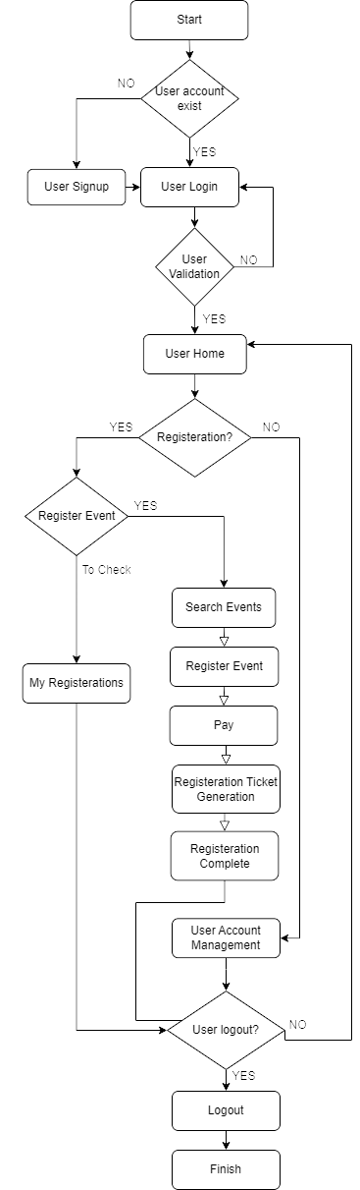

**Fig 4.1 :** Flow Chart of “End user registration with acknowledgement Module”

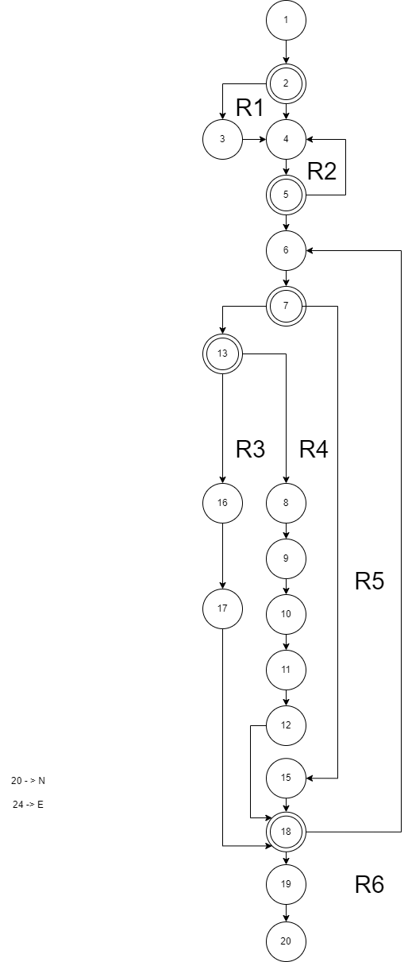

**Fig 4.2:** Flow graph for the module “End user registration with acknowledgement Module”

**COMPUTATION OF CYCLOMATIC COMPLEXITY**

1. Number of regions in the Flow-Graph = **6**
2. V(G) = E – N + 2

where,

* + 1. E is Number of edges in the flow graph
    2. N is the Number of nodes in the flow graph
    3. V(G) is the Cyclomatic Complexity

E =24, N = 20

V(G) = 24 – 20 + 2 = **6**

1. V(G) = P + 1

P – Number of Predicate nodes in the flow chart

P = 5

V(G) = 5 + 1 = **6**

**FLOW PATH**

Number of flow paths = 2 * P + 1 = 10 + 1 = 11

SIGN UP

Path 1 - If account exists

1->2->4->->5->6->7->15->18->19->20

Path 2 - If account doesn’t exist

1->2->3->4->5->6->7->15->18->19->20

LOG IN  
Path 3 - If authentication failed

1->2->4->5->4->5->6->7->15->18->19->20

Path 4 -If authentication not failed

1->2->4->5->6->7->15->18->19->20

MANAGE ACCOUNT

Path 5 -Manage account and Return home

1->2->4->5->6->7->15->18->6->7->13->16->17->18->67->13->16->17->18->19->20

Path 6 -Manage account and Logout

1->2->4->5->6->7->15->18->19->20

REGISTER EVENT

Path 7 -Register event and Return home

1->2->4->5->6->7->13->8->9->10->11->12->18->67->13->16->17->18->67->13->16->17->18->19->20

Path 8 -Pdf generation

1->2->4->5->6->7->13->8->9->10->11->12->18->19->20

Path 9 -Register event and Logout

1->2->4->5->6->7->13->8->9->10->11->12->18->19->20

REGISERATTIONS

Path 10 - Check Registerations and Return home

1->2->4->5->6->7->13->16->17->18->6->7->13->16->17->18->19->20

Path 11 - Check Registerations and Logout

1. >2->4->5->6->7->13->16->17->18->19->20

**DEVELOPMENT EFFORT ESTIMATION BY ORGANIC METHOD:**

Effort **=** 2.4(KLOC)1.05 PM

KLOC = 1 KLOC

Effort = 2.4 *1*1.05 PM

Effort = 2.52 PM

**DEVELOPMENT TIME ESTIMATION BY ORGANIC METHOD:**

Tdev = 2.5(Effort)0.38 Weeks

Tdev = 2.5 *2.52* 0.38

Tdev = 2.394 weeks

Likewise, it is done for all the activities of the project UEMTS.

**ACTIVITY CHART**

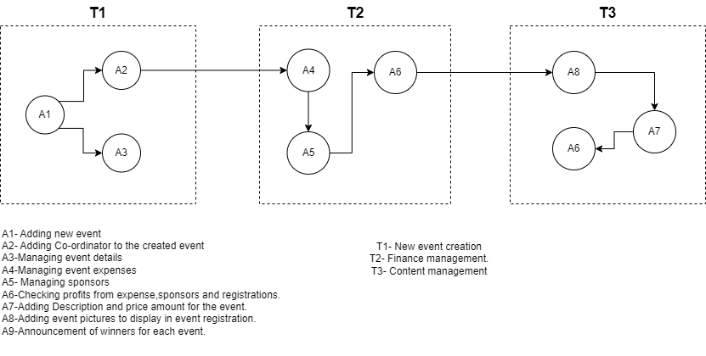

**Fig 4.3:** Activity Chart

Likewise, it is done for all the tasks of the UEMTS.

**TASK DEPENDENCY CHART**

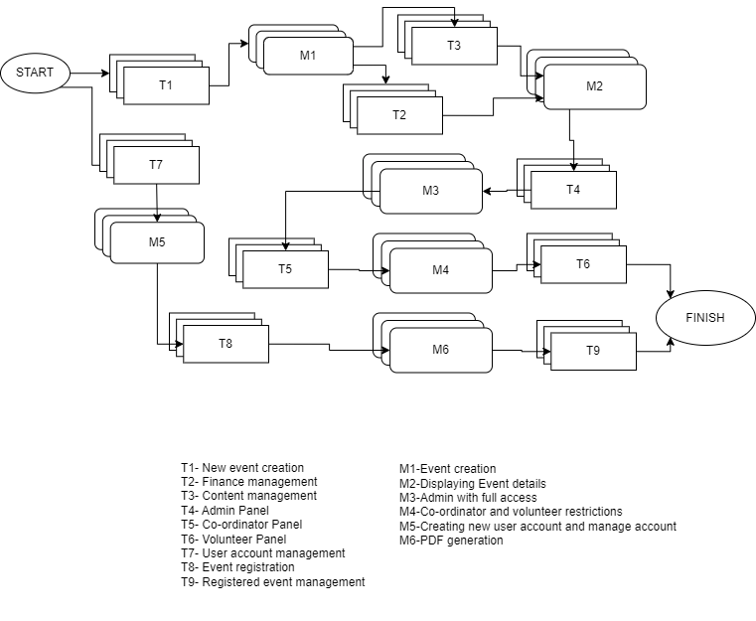

**Fig 4.4:** Task Dependency Chart

**TASK DEPENDENCY TABLE**

|  |  |  |
| --- | --- | --- |
| **TASK** | **DURATION(DAYS)** | **DEPENDENCIES** |
| T1 | 5 | **-** |
| T2 | 2 | T1(M1) |
| T3 | 1 | T1(M1) |
| T4 | 3 | T2(M2), T3(M2) |
| T5 | 1 | T4(M3) |
| T6 | 3 | T5(M4) |
| T7 | 4 | - |
| T8 | 2 | T7(M5) |
| T9 | 2 | T8(M6) |

**DEVELOPMENT EFFORT ESTIMATION BY ORGANIC METHOD:**

Effort **=** 2.4(KLOC)1.05 PM

KLOC = 6 KLOC

Effort = 2.4 *6*1.05 PM

Effort = 15.12 PM

**DEVELOPMENT TIME ESTIMATION BY ORGANIC METHOD:**

Tdev = 2.5(Effort)0.38 weeks0

Tdev = 2.5 *15.12* 0.38

Tdev = 14.364 weeks

**Unit testing**

Unit testing is performed to validate the smallest testable parts of the software. It ensures that each unit performs as expected according to design specifications.

**End user registration with selection acknowledgement Module**

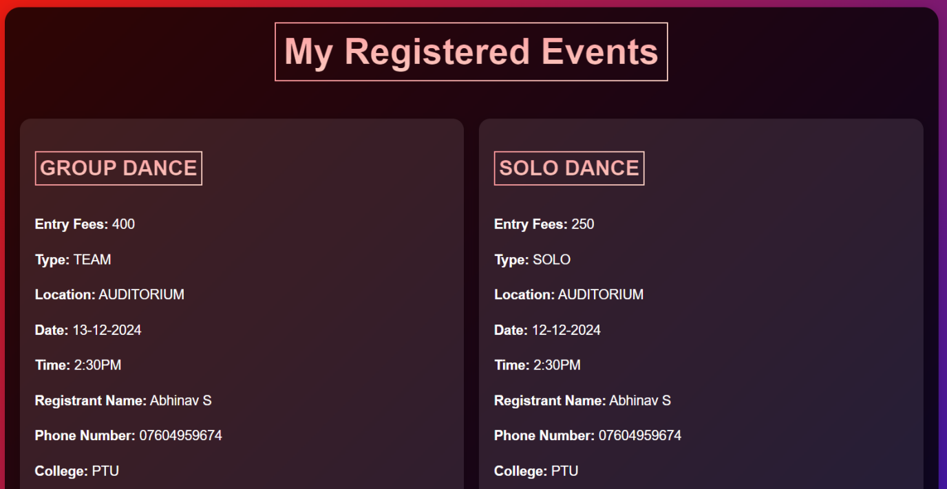

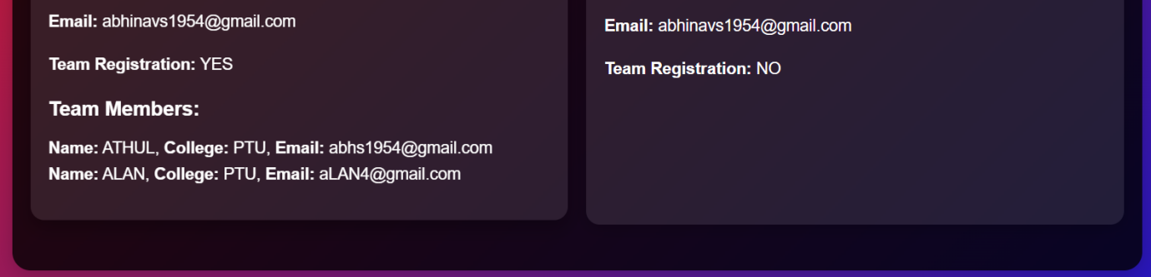

**Fig 4.3: User registered events**

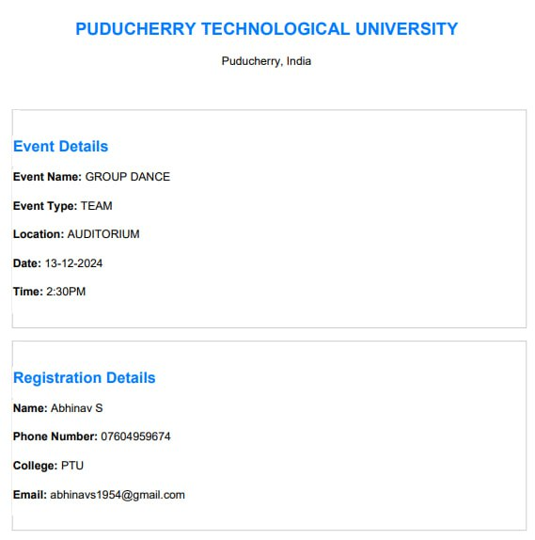

**Fig 4.4: PDF Generated for registered event**

**Event management module:**

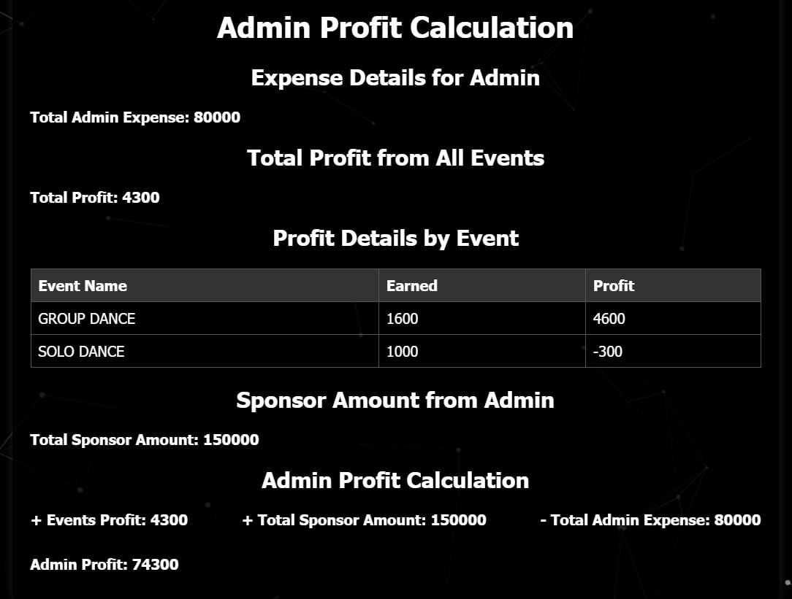

**Fig 4.5: Event Details**

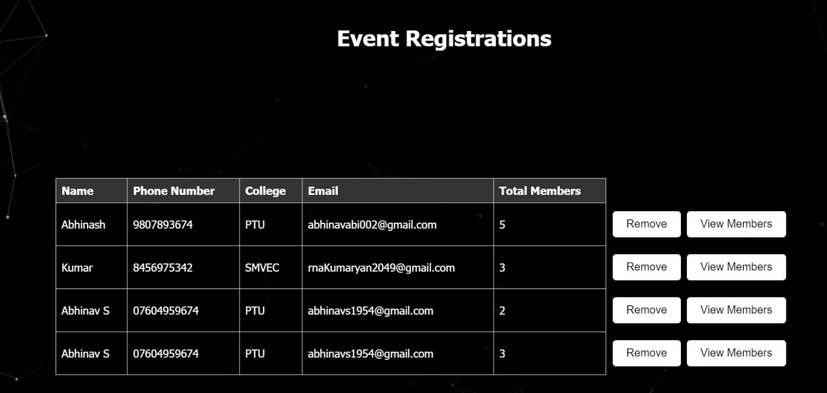

**Fig 4.6: Registered user details**

**Role based Admin monitoring System:**

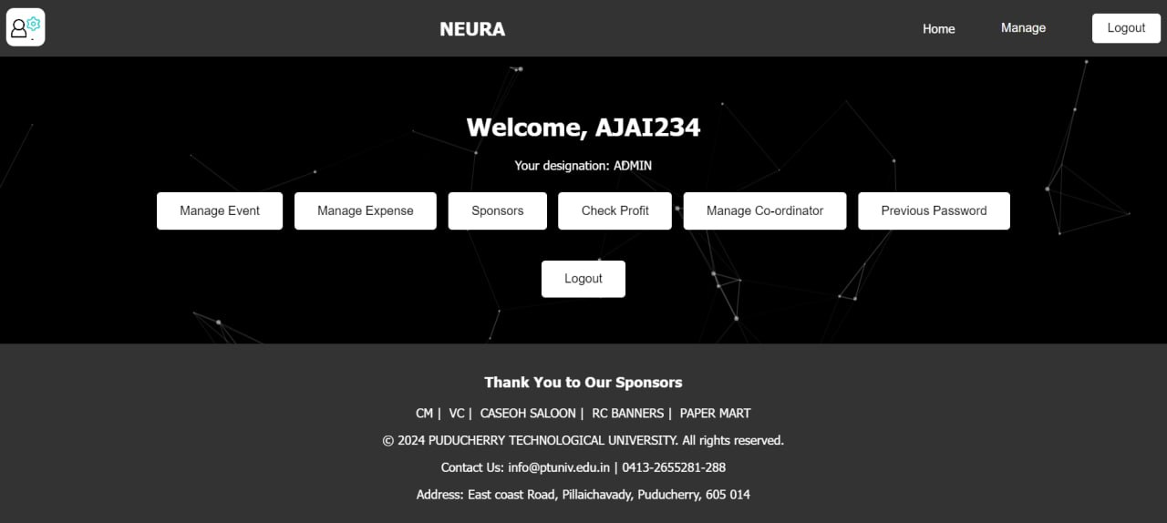

**Fig 4.7: Admin view**

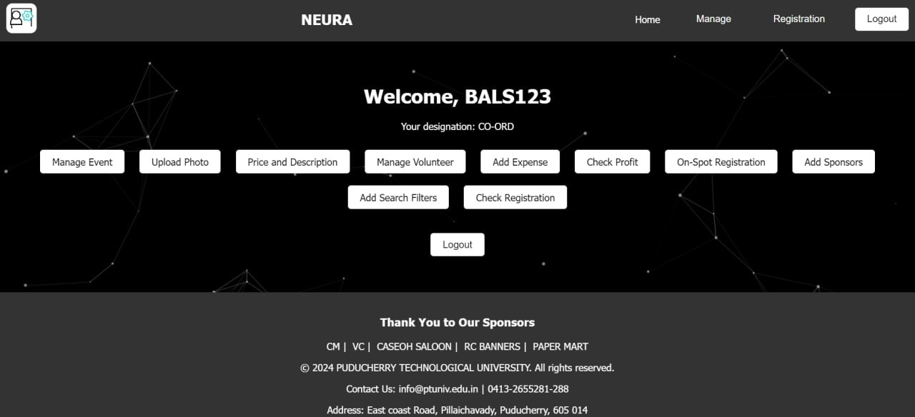

**Fig 4.8: Coordinator view**



**Fig 4.9: Volunteer view**

**Integrated testing**

Integrated testing involves testing different modules or components of a software system together to ensure they work seamlessly as a whole. It validates interactions between integrated components to detect any inconsistencies or issues that may arise at their interfaces.

**Event management module:**

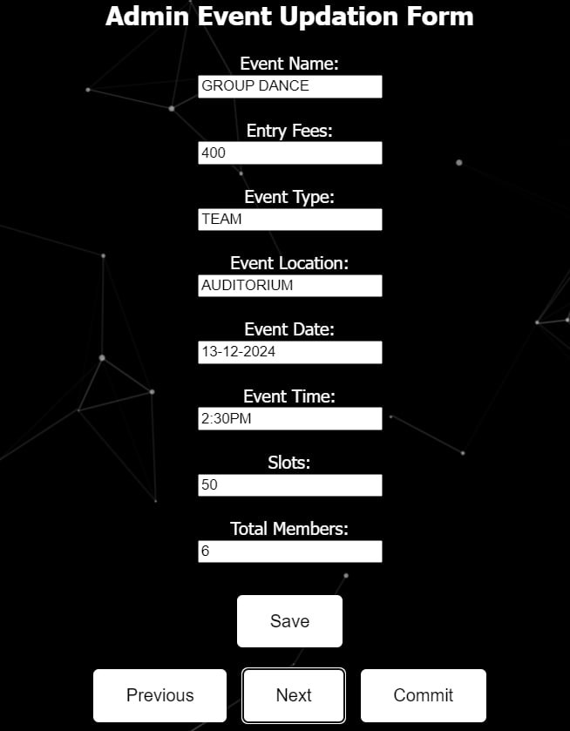

**Fig 4.10 Adding Event Form**

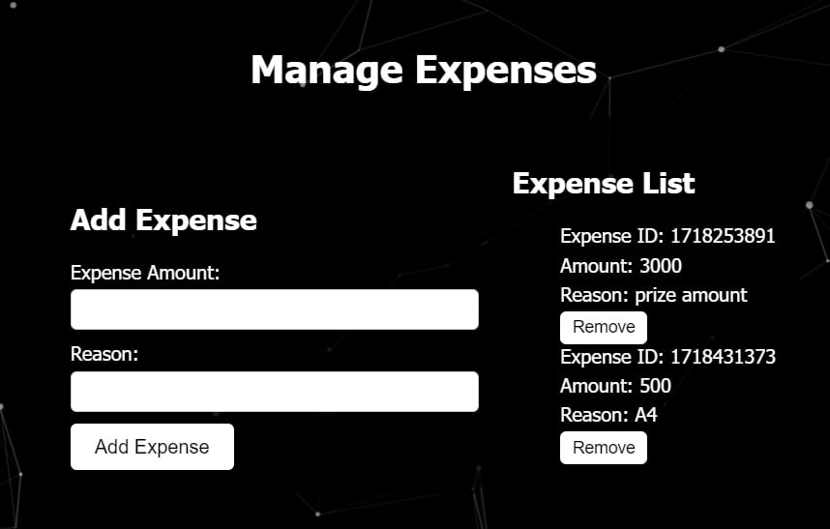

**Fig 4.11 Expense Management**

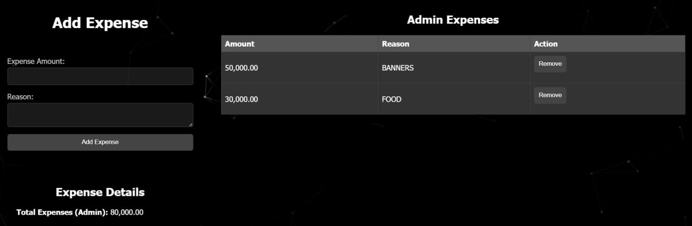

**Fig 4.12 Sponsor Management**

**End user registration with selection acknowledgement Module :**

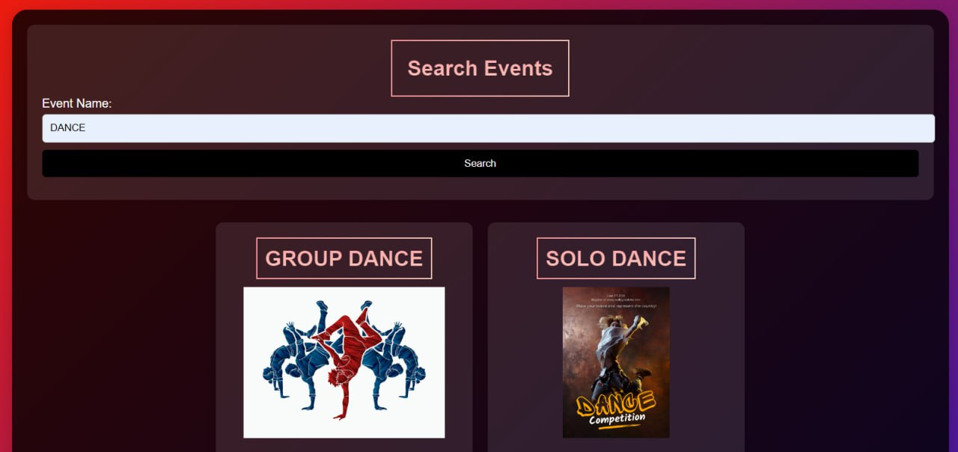

**Fig 4.13 - Search Event**

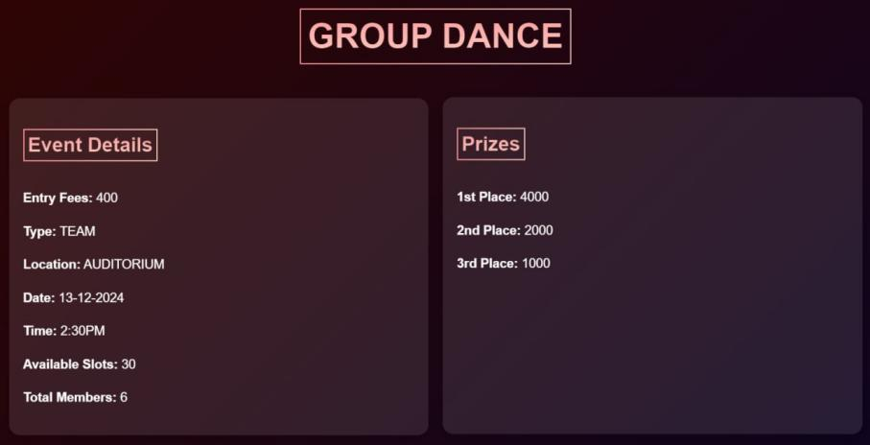

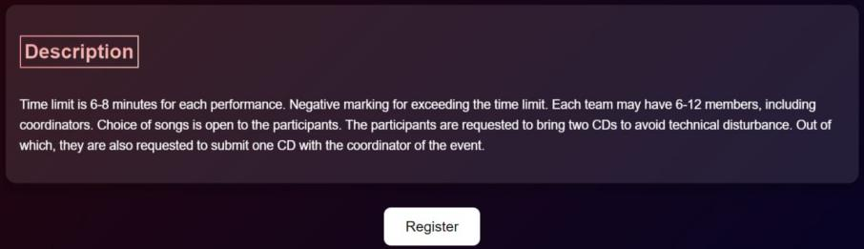

**Fig 4.14 - Desired Event Details To Register**



**Fig 4.15 - Generated Pdf after Registeration**

**Role based Admin monitoring System:**



**Fig 4.16 - Admin View**



**Fig 4.17 - Co-ord View**

**Smoke Testing**

As a critical component of white box testing, smoke testing validates that essential software functionalities perform as expected, providing an initial gauge of software stability before deeper testing commences. Daily execution of smoke tests ensures timely detection and resolution of any issues, facilitating consistent progress and upholding stringent quality assurance benchmarks in the project's lifecycle.

**UEMTS Project Result**

**Black box testing**

**Event management module:**

Enables expense analysis and categorization into predefined categories, aiding budget management.



**Fig 4.17 - Event Details for Admin**

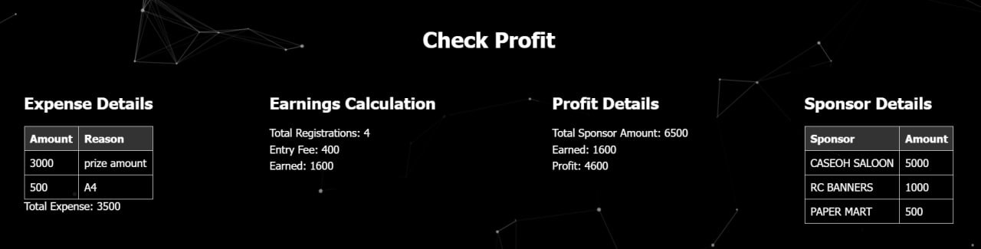

**Fig 4.18 - Event Details for Co-ord**

**End user registration with selection acknowledgement Module :**

Integrates a chatbot for expense management assistance and bill reminders via push notifications.



**Fig 4.19 - Search Event**



**Fig 4.19 - Pdf Generation after Registeration**

**Role based Admin monitoring System:**

Using linear regression, the Future Expense Prediction Module forecasts upcoming expenses based on historical data, empowering users with proactive financial insights for better budgeting and decision-making.



**Fig 4.20 Admin View**



**Fig 4.21 Co-ord View**



**Fig 4.22 Volunteer View**

**Conclusion**

The University Event Monitoring and Tracking System provides a comprehensive solution to streamline event management, enhance user engagement, and ensure efficient administrative oversight. By integrating three robust modules—Event Management, End User Registration with Selection Acknowledgment, and Role-Based Admin Monitoring—the system addresses key challenges in organizing and managing university events.

Overall, this system fosters a collaborative environment, minimizes administrative burdens, and enhances the overall efficiency of event management within the university. By implementing this project, the university can ensure seamless event execution, improved user satisfaction, and optimized resource utilization, ultimately contributing to a more vibrant and organized campus life.

The Event Management module simplifies the process of planning, scheduling, and coordinating events, providing a centralized platform for event organizers. The End User Registration module enhances user experience by enabling easy event registration and generating personalized PDF confirmations, which are readily accessible through a user-friendly interface. The Role-Based Admin Monitoring module ensures effective oversight by assigning specific roles and access controls, allowing for a hierarchical management structure that promotes accountability and efficient coordination among admins, coordinators, and volunteers.

**REFERENCES :**

1.Abraham Silberschatz, Henry F. Korth, and S. Sudarshan. (2010). Database System Concepts.

2.Andrews, R. (2019). "Event Management in Higher Education: Challenges and Opportunities." Journal of Higher Education Administration, 35(2), 87-102.

3.Basso, J., et al. (2018). "Improving Event Management Processes Through Technology: A Case Study." Journal of Event Management, 10(2), 87-102.

4.Barker, K., & O'Brien, S. (2020). "Enhancing Event Coordination Through Technology: A Case Study." International Journal of Event Management Research, 8(1), 45-58.

5.Chen, L., et al. (2018). "Digital Solutions for Event Planning: A Review of Literature." Journal of Information Technology and Event Management, 12(2), 102-115.

6.Davidson, M., et al. (2017). "Improving Efficiency in University Events Through Technology Integration." Journal of Educational Technology Research, 45(3), 211-225.

7.Edwards, H., & Smith, J. (2021). "Event Management Systems: A Comprehensive Review." Journal of Event Technology, 14(1), 30-45.

8.Fletcher, A., & Brown, M. (2019). "Streamlining Event Registration Processes: Best Practices and Challenges." Journal of Event Management, 11(2), 132-145.

9.Garcia, S., et al. (2020). "Role-Based Admin Monitoring Systems: Design and Implementation Strategies." International Journal of Human-Computer Interaction, 34(4), 276-289.

10.Hall, R., & Johnson, E. (2018). "User Experience Design Principles for Event Management Systems." Journal of User-Centered Design, 22(3), 150-165.

11.Ibrahim, N., et al. (2020). "Integrating Event Management Systems with University Portals: A Case Study." Journal of Educational Technology Integration, 38(1), 45-58.

12.Jackson, K., & White, L. (2019). "Enhancing Collaboration in University Events: Insights from Case Studies." Journal of Collaboration Research, 21(2), 89-104.

13.Kim, Y., & Park, S. (2017). "Event Management Trends and Innovations: A Comprehensive Overview." Journal of Event Technology, 10(1), 25-40.

14.Kim, Y., & Park, S. (2020). "Emerging Trends in Event Management Technology: A Review." Journal of Information Technology and Event Management, 12(1), 45-58.

15.Lee, H., & Lee, S. (2018). "Artificial Intelligence in Event Planning: Applications and Implications." Journal of Artificial Intelligence Research, 35(2), 120-135.

16.Martinez, A., et al. (2021). "Event Management Systems and Student Information Integration: A Case Study." Journal of Information Systems Integration, 39(3), 210-225.

17.Nguyen, T., & Smith, P. (2019). "User-Centered Design Principles for Event Management Systems: A Comparative Study." Journal of Usability Engineering, 28(4), 180-195.

18.MySQL :: The World's Most Popular Open Source Database. [Online]. Available: https://www.mysql.com/.

19.PHP: Hypertext Preprocessor. [Online]. Available: https://www.php.net/.

20.www.geekforgeeks.com.

21.www.w3schools.com.